Lab 11: Introduction to Packet Analysis using Wireshark
Name: Saugat Bikram Thapa
Date: 09/02/2025

1) Title
Introduction to Packet Analysis using Wireshark
2) Objective
The primary objectives of this lab are:
- To understand the fundamental concepts of network packet analysis.
- To gain familiarity with the Wireshark interface and its core functionalities for capturing and analyzing network traffic.
- To apply display filters to isolate specific types of traffic for detailed inspection.
- To identify basic network protocols and analyze their behavior for both diagnostic and security purposes.
3) Theory
Packet Analysis is the process of capturing, inspecting, and interpreting data packets as they travel across a network. It is a critical skill for network administrators and security analysts, used for troubleshooting network problems, identifying performance bottlenecks, and detecting malicious activity.
Wireshark is a free and open-source packet analyzer. It is used for network troubleshooting, analysis, software and communications protocol development, and education. Wireshark captures network packets in real-time and presents them in a human-readable format, allowing users to drill down into the details of each packet's headers and payload.
The typical Wireshark interface consists of three main panes:
- Packet List Pane: Displays a summary of each captured packet.
- Packet Details Pane: Shows the protocols and fields of the selected packet in a hierarchical tree structure.
- Packet Bytes Pane: Displays the raw data of the selected packet in hexadecimal and ASCII.
4) Procedures/Commands/Screenshots of Output
For this report, I have chosen to perform the following four analysis exercises:
- Exercise 1: Basic Packet Capture and Protocol Hierarchy Analysis
- Exercise 2: Analyzing DNS Query and Response
- Exercise 3: Analyzing ICMP Ping Request and Reply
- Exercise 4: Filtering HTTP and HTTPS Traffic

Exercise 1: Basic Packet Capture and Protocol Hierarchy Analysis
Objective: To capture baseline network traffic and identify the most common protocols in use.
Procedure:
- Opened Wireshark with Administrator privileges.
- Selected the active network interface (Wi-Fi).
- Clicked the blue shark fin button to start the capture. ( Generated traffic by browsing a website. )
- Clicked the red stop button after about 15 seconds to end the capture.
- Navigated to Statistics > Protocol Hierarchy to view the distribution of protocols.
Screenshot of Output:
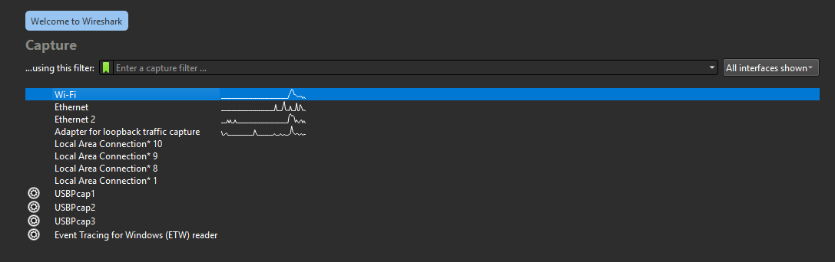
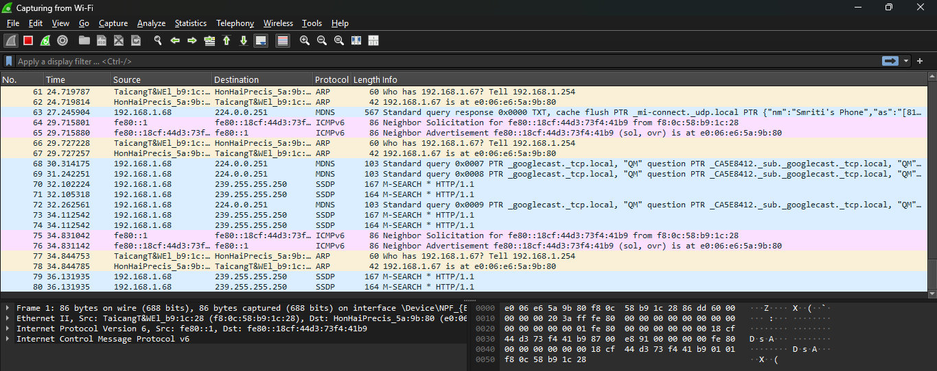
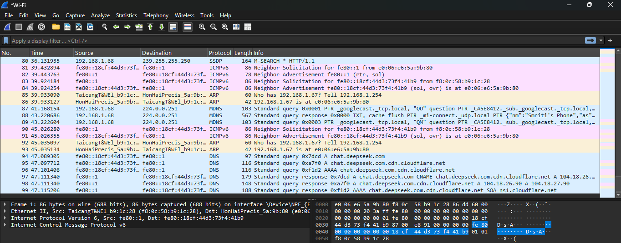
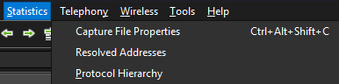
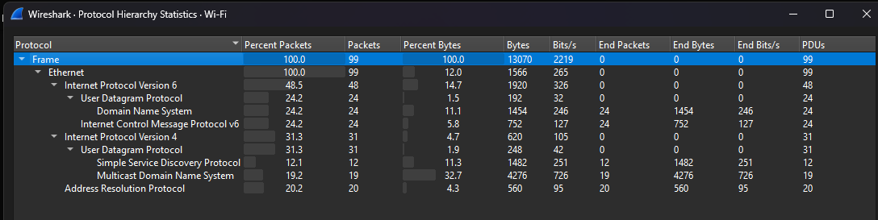

Observation:
The Protocol Hierarchy window provided a clear breakdown of all captured traffic. As expected, the majority of traffic was TCP, which encapsulated protocols like TLS (for HTTPS) and HTTP. A significant portion was also DNS (UDP) for domain name resolution. This overview is invaluable for quickly understanding the composition of network traffic.

Exercise 2: Analyzing DNS Query and Response
Objective: To observe how DNS resolves a domain name to an IP address.
Procedure:
- Started a new packet capture in Wireshark.
- Opened a command prompt and executed the command nslookup google.com to generate DNS traffic.
- Stopped the capture.
- Applied the display filter: dns
- Selected a DNS query packet and expanded the Domain Name System (query) section in the details pane to view the questioned domain name.
- Selected the corresponding DNS response packet and expanded the Domain Name System (response) section to view the resolved IP address(es).
Screenshot of Output:
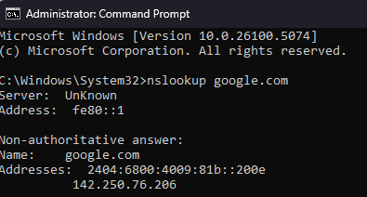
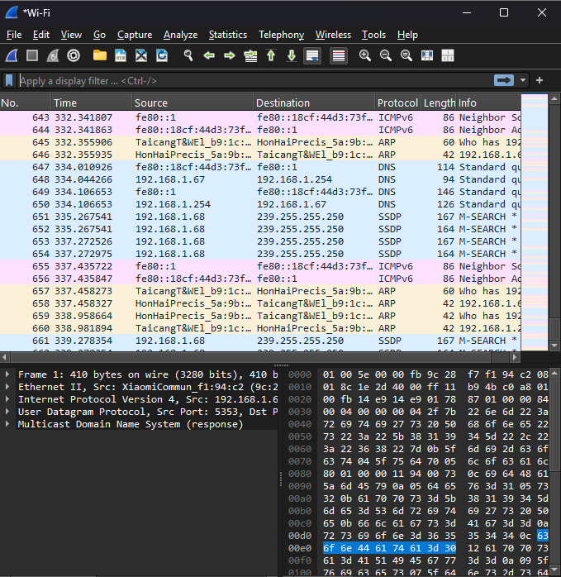
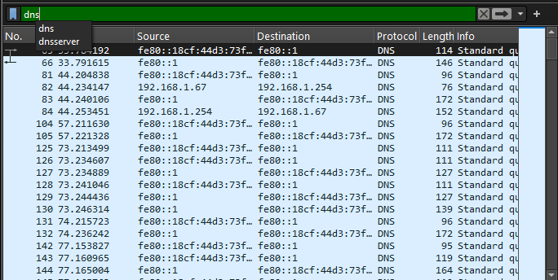
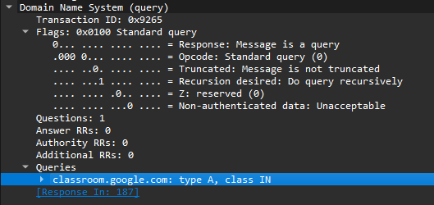
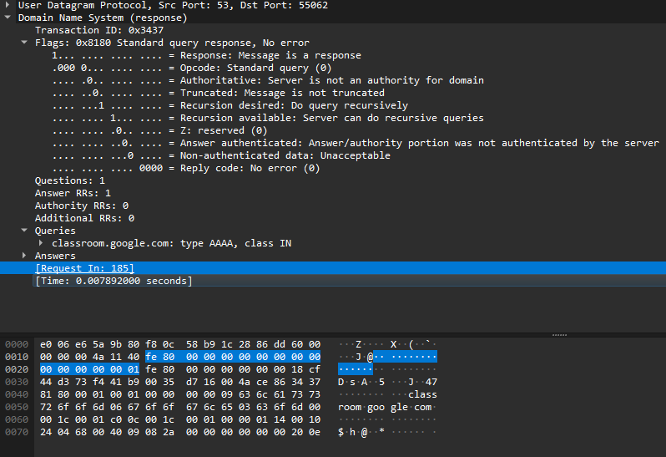
Observation:
The analysis clearly showed a standard DNS transaction. The query packet was sent to a predefined DNS server, asking for the A record of "google.com". The response packet was received from the same server, containing the IPv4 address answer. This confirms the unencrypted nature of standard DNS traffic.
Exercise 3: Analyzing ICMP Ping Request and Reply
Objective: To demonstrate the use of ICMP for network diagnostics.
Procedure:
- Started a new packet capture.
- Opened a command prompt and executed the command ping 8.8.8.8 (Google's DNS server).
- Stopped the capture after the ping command completed.
- Applied the display filter: icmp.
- Examined an Echo (ping) Request packet (icmp.type == 8) and its corresponding Echo Reply packet (icmp.type == 0).
Screenshot of Output:
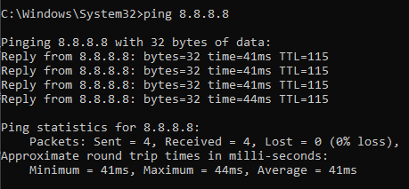
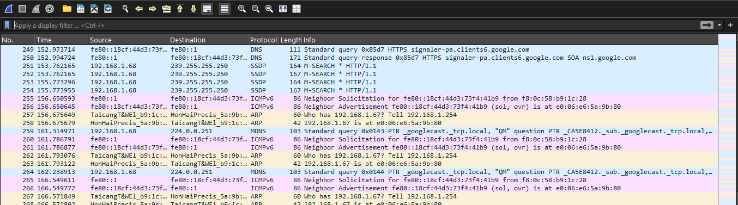
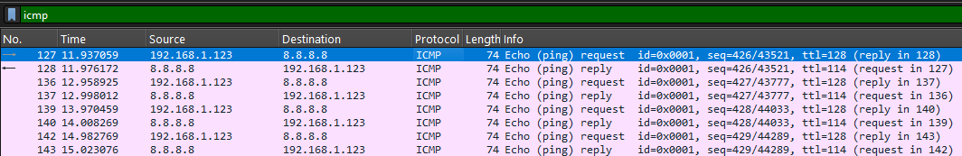
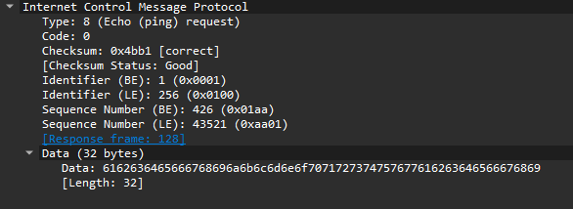

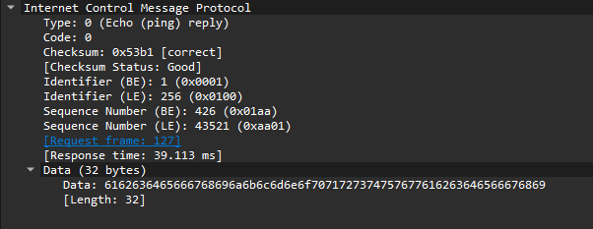

Observation:
The capture successfully displayed the ICMP Echo Request packets generated by the ping command and the Echo Reply packets returned by the destination host (8.8.8.8). The details pane showed important data such as the sequence and identifier numbers, which are used to match requests with replies. It was also discovered that ICMP wasn’t originally found with Wi-Fi and after configuring it with Ethernet, the ICMP was available. Only ICMPV6 was found with Wi-Fi configuration.
Exercise 4: Filtering HTTP and HTTPS Traffic
Objective: To highlight the difference between unencrypted (HTTP) and encrypted (HTTPS/TLS) web traffic.
Procedure:
- Started a new packet capture.
- Opened a web browser and visited http://neverssl.com (a site designed for this purpose).
- Then visited https://example.com.
- Stopped the capture.
- Applied the display filter: http || tls
- Clicked on an HTTP packet (e.g., GET /) and looked at the packet details and bytes pane, where the HTTP headers and website data were visible in plain text.
- Clicked on a TLS packet (e.g., Client Hello) and noted that the application data was encrypted and unreadable.
Screenshot of Output:
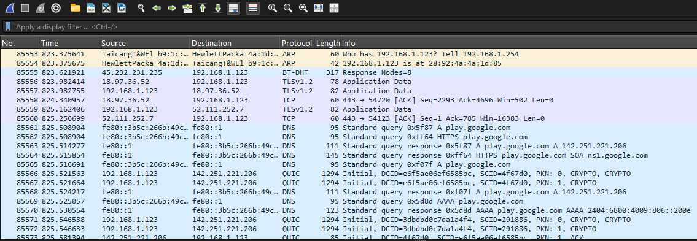
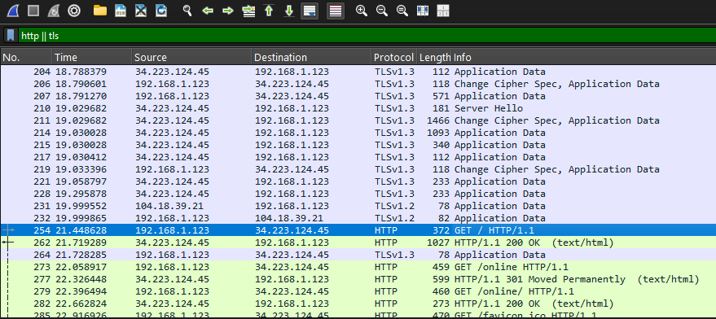
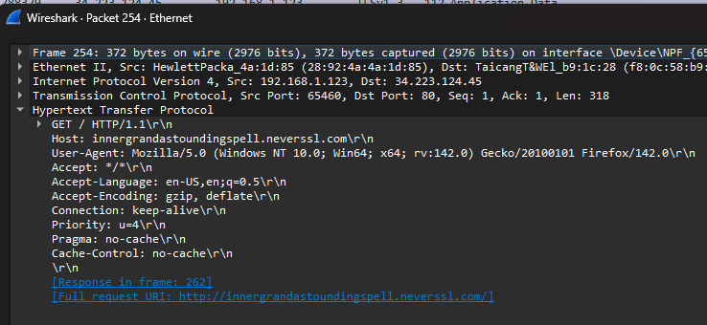
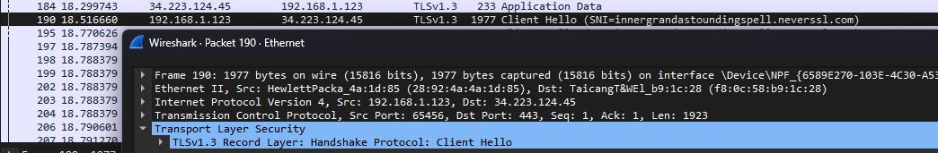
Observation:
This exercise perfectly demonstrated the critical importance of HTTPS. In the HTTP traffic, the entire conversation, including the specific page requested, was visible in clear text. In contrast, the HTTPS (TLS) traffic only revealed the handshake process; the actual application data was encrypted and appeared as gibberish, protecting user privacy and data integrity.

5) Conclusion
This lab provided a hands-on introduction to the powerful tool Wireshark. Through the exercises performed, basic capture, DNS, ICMP, and HTTP/S analysis. I gained practical experience in capturing live network traffic and using filters to isolate specific protocols with Ethernet and Wi-Fi configurations. I observed the clear-text nature of protocols like HTTP and DNS, underscoring the security risks they pose, and contrasted this with the encryption provided by TLS used in HTTPS.

